Reproducible Research First Assignment

Khaled Alzafari

September 16, 2015

## load the Data:

echo = TRUE  
mydata= read.csv(file="activity.csv", header=TRUE, sep=",")

## Histogram for the total number of steps per day:

echo = TRUE  
totalSteps <- aggregate(steps ~ date, data = mydata, sum, na.rm = TRUE)  
library(ggplot2)

## Warning: package 'ggplot2' was built under R version 3.2.2

ggplot(data=totalSteps, aes(totalSteps$steps)) + geom_histogram( col="black", fill="red", alpha = 0.3, binwidth=1500) + labs(title="Histogram for Total Steps Per Day") + labs(x="Total Steps", y="Count") + geom_density(alpha=0.9)

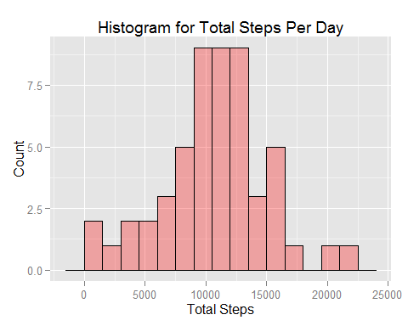

## the mean and median total number of steps taken per day:

echo = TRUE  
Mean_steps = mean(totalSteps$steps, na.rm = TRUE)  
Median_steps = median(totalSteps$steps, na.rm = TRUE)  
Mean_steps

## [1] 10766.19

Median_steps

## [1] 10765

## The average daily activity pattern:

echo = TRUE  
meanSteps <- aggregate(steps ~ interval, data = mydata, mean, na.rm = TRUE)  
  
dp= ggplot(meanSteps, aes(meanSteps$interval, meanSteps$steps))+ geom_line(col="red", fill="red", alpha = 0.5)   
dp + labs(title="Time seires for Average number of steps Taken at 5 minute Intervals") + labs(x="T5-min interval", y="average number of steps taken")

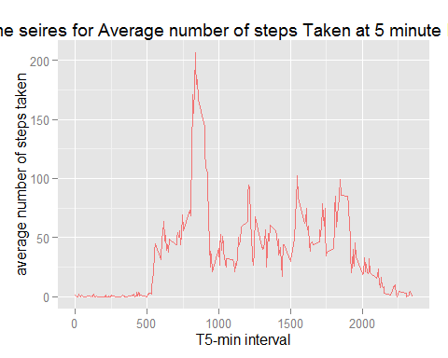

## Which 5-minute interval, on average across all the days in the dataset, contains the maximum number of steps?

echo = TRUE  
maxinterval = meanSteps[which.max(meanSteps$steps), ]  
maxinterval

## interval steps  
## 104 835 206.1698

### It is the interval number 835 that has the value of 206.2

## Imputing missing values

### Number of Missing Value

echo = TRUE  
missing_rows <- sum(!complete.cases(mydata))  
missing_rows

## [1] 2304

## Devise a strategy for filling in all of the missing values in the dataset the new stratgy depend on replace NA with the mean of the "steps" variable

echo = TRUE  
newdataset= mydata  
newdataset$steps[which(is.na(newdataset$steps))] = mean(newdataset$steps, na.rm = T)

## histogram for the new Data Set:

echo = TRUE  
newtotalSteps <- aggregate(steps ~ date, data = newdataset, sum, na.rm = TRUE)  
library(ggplot2)  
ggplot(data=newtotalSteps, aes(newtotalSteps$steps)) + geom_histogram( col="black", fill="blue", alpha = 0.3, binwidth=1500) + labs(title="Histogram for Total Steps Per Day") + labs(x="Total Steps", y="Count") + geom_density(alpha=0.9)

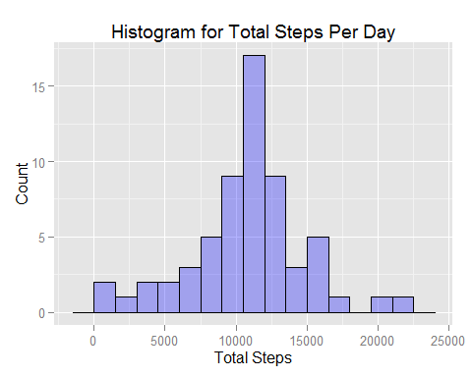

## The mean and median total number of steps taken per day for the new data set:

echo = TRUE  
newMean_steps = mean(newtotalSteps$steps)  
newMedian_steps = median(newtotalSteps$steps)  
newMean_steps

## [1] 10766.19

newMedian_steps

## [1] 10766.19

## What is the impact of imputing missing data on the estimates of the total daily number of steps?

### The mean for both data (before and after removing missing Data NA) while our strategy was based on replacing NA with the mean of the same variable.whereas, the there is a small difference for the median before removeing NA and after.

## Are there differences in activity patterns between weekdays and weekends?

echo = TRUE  
newdataset$days= weekdays(as.Date(newdataset$date))  
library(plyr)

## Warning: package 'plyr' was built under R version 3.2.1

newdataset$weeks <- revalue(newdataset$days, c("Saturday"="weekend", "Sunday"="weekend", "Monday"="weekday", "Tuesday"="weekday", "Wednesday"="weekday","Thursday"="weekday", "Friday"="weekday" ))  
newmeanSteps <- aggregate(steps ~ interval + weeks, data = newdataset, mean, na.rm = TRUE)  
  
library(ggplot2)  
X1 = ggplot (newmeanSteps, aes(newmeanSteps$interval, newmeanSteps$steps, colour = newmeanSteps$weeks) ) + geom_line()   
X1 + labs(title="Average number of steps Taken at 5 minute Intervals") + labs(x="T5-min interval", y="average number of steps taken") + labs(colour="Type of week Day")

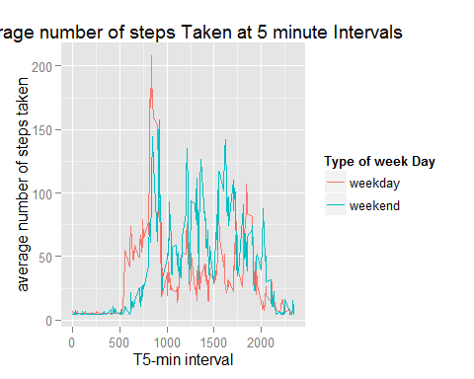

### The difference is clear between the normal working days and weekend days...